VIgo4AI: Visually Impaired go for Artificial Intelligence

Project number: 2024-1-AT01-KA220-ADU-000255271

Evaluation of a survey on the experiences of professionals and experts in the service and education sector for visually impaired people regarding artificial intelligence

|  |  |
| --- | --- |
| Executing organization: | Berufsförderungswerk Düren gGmbH Karl-Arnold-Strasse 132-134 52349 Düren Germany |
| Date of publishing | February 2025 |
| Version: | 25 - 02 – Version 1.1 |

Content

1 Background 4

2 Methodology 5

2.1 Structure, and selection of items 6

2.2 Design of the online questionnaire 6

2.3 Sampling procedure 7

3 Short Survey Summary 8

3.1 Overview of the main results 8

3.2 Note on the survey results 9

4 Analysis of differences in preference for AI - based on professional experience 10

5 Detailed evaluation 11

5.1 Section 1 – General Information 11

5.1.1 Primary Occupation 11

5.1.2 Country of residence 13

5.1.3 Experience in work with the target group 14

5.1.4 Familiarity in using technology 15

5.1.5 Assistive technology used in supporting target group 16

5.2 Section 2 - Use of AI Mainstream Apps to Facilitate Education 18

5.2.1 Utilisation of AI in training 18

5.2.2 AI Software in use 19

5.2.3 Effectiveness of these AI for educational needs of visually impaired people 21

5.2.4 Required features of AI to support work (Open question) 22

5.3 Section 3: Use of AI Mainstream Apps to Facilitate Work 23

5.3.1 Recommendation of AI to support visually impaired in working environment 23

5.3.2 Useful features in AI to facilitate work 24

5.3.3 Encountered challenges while using or recommending AI for workplace? (Open question) 26

5.3.4 Suggested improvements for AI to use at workplace? (Open question) 27

5.4 Section 4: Use of AI Mainstream Tools to Facilitate Everyday Life 28

5.4.1 Recommendation of AI to support visually impaired in everyday life 28

5.4.2 Effective support of AI in tasks of everyday life 29

5.4.3 Limitations of AI for support everyday life? (Open question) 31

5.5 Section 5: Use of AI Tools to Generate Pictures 32

5.5.1 Recommendation to use AI to generate tactile or descriptive images 32

5.5.2 Importance of AI to create visual content for visually impaired users 33

5.5.3 Utilised AI to generate tactile or descriptive images (Open question) 34

5.6 Section 6: Concerns About Data Privacy 35

5.6.1 Concerns about using AI supportet Apps 35

5.6.2 Reasons for concerns about data privacy when using AI 36

5.6.3 Willingness to use AI despite of data privacy concerns 37

5.7 Section 7: Open Feedback 38

5.7.1 What are your overall expectations from AI tools to better support your work with visually impaired individuals? (0pen question) 38

6 Remarks 39

7 Bibliography 39

8 Annex 39

# Background

This survey was part of the ERASMUS+ funded project ‘Visually Impaired go for Artificial Intelligence’ (abbreviation: Vigo4AI). According to the work plan, this survey was realised in the first two months of the project, from December 12th,2024 to February 12th, 2025.

The aim of this survey was determined in the project application to „Report on research about the applicability of AI-apps and tools for visually impaired and blind people."

In detail, the results of this survey should provide the following information:

1. Overview of experiences in using AI tools among the professionals in their daily work for their visually impaired clients
2. Overview of the AI tools which are used by the professionals
3. Assessment of the ability of AI to facilitate the education of visually impaired people
4. Assessment of the ability of AI to facilitate the professional working situation of visually impaired people
5. Assessment of the ability of AI to facilitate the life of visually impaired people
6. Overview of the AI application areas to facilitate the situation of the target group
7. Overview of the commonly used AI software and their application areas
8. Concerns regarding the use of AI applications in terms of data privacy
9. Feedback on expectations of AI in terms of improving the work of professionals to support visually impaired clients

The evaluation of this survey should help to ensure that:

1. The three curricula to be developed are based on the experiences of the respondents regarding:

* the AI apps used and popular
* difficulties encountered when operating the AI apps
* expectations regarding the fulfilment of tasks

1. the three tutorials and e-learning contents to be developed are based on the aspects listed above under point 1.

The evaluation therefore also supports the requirements of the

EU Artificial Intelligence Act. This law, which will come into force on February 1st, 2025 determines:

“Providers and deployers of AI systems shall take measures to ensure, to their best extent, a sufficient level of AI literacy of their staff and other persons dealing with the operation and use of AI systems on their behalf, taking into account their technical knowledge, experience, education and training and the context the AI systems are to be used in, and considering the persons or groups of persons on whom the AI systems are to be used.” (European Parliament and Council of the European Union, 2024, p. 51)

In this context, a deployer is not defined as a manufacturer or supplier, but rather:

‘”deployer’ means a natural or legal person, public authority, agency or other body using an AI system under its authority except where the AI system is used in the course of a personal non-professional activity” (European Parliament and Council of the European Union, 2024, p. 47)

Thus, it can be assumed that a precise adjustment of the curricula and tutorials to be developed will make a significant contribution to ‘AI-literacy’ of professionals. In this case, the results of this project will provide essential support for service providers and educational organisations in implementing this EU law for professionals working with visually impaired people. This is becoming all the more important given that the use of AI in healthcare systems and e-learning platforms with assessment options is classified as critical AI under the above-mentioned EU regulation (Annex III). This requires in particular the qualification of the responsible personnel. (see EUROPEAN UNION, 2021, p.4)

# Methodology

The survey was implemented online using the platform ‘umfrageonline.com’ as an online questionnaire. The items of the questionnaire were created in English. Since the common web browsers offer online translations, this should ensure that the online questionnaires can be answered in all national languages. Thus, translations into several national languages were not necessary. In addition, paper printouts were not required from an ecological point of view and in accordance with the ‘Green ERASMUS+’ principle. If the participating partner organisations involved a group of participants in the survey who either did not have the option of answering online or did not want to answer online, corresponding templates in PDF format were made available online. These could then be printed out by the partner organisations if necessary and completed by means of an interview.

At the end of the survey period, the results were downloaded from the platform as an Excel spreadsheet file. The evaluation was then carried out using this data pool and process it with the statistical software SPSS.

The following project partners were responsible for conducting the survey of experts in their country:

1. Hilfsgemeinschaft der Blinden und Sehschwachen Österreichs, Austria
2. Berufsförderungswerk Düren gGmbH, Germany
3. VIDEBIS GmbH, Austria
4. Zavod, IZRIIS, Slovenia

The content of three questionnaires for experts was submitted as an Excel spreadsheet by the project partner from Slovenia. They did not collect the data from experts using the online questionnaire. The Slovenian partners acquired the data by interview with experts using the printouts of the questionnaire. The interviews were conducted on site, during visits to the experts who are connected to the network of the Slovenian partner organization. Employees completed the questionnaires. First, the employees explained the process to the experts and translated question by question. The answers were then entered into the questionnaire and the open questions/answers were also translated directly. The results of those three questionnaires, were added to the data pool.

## Structure, and selection of items

The questionnaire consisted of seven sections:

1. General information, covering information about occupation, country, experience in working with visually impaired people and experience in using technology (also assistive devices) in their work
2. Use of AI Tools to facilitate education
3. Use of AI Tools to facilitate work of visually impaired people
4. Use of AI Tools to facilitate everyday life of visually impaired people
5. Use of AI to generate pictures by visually impaired user
6. Concerns About Data Privacy
7. Open feedback, covering open questions about expectations concerning AI features to improve work to support visually impaired clients

The questionnaire covered 17 items. 10 of these questions were asked in binary form, and 7 were asked as possible multiple answers. In addition, the respondents could enter their own comments on the subject areas in 6 open questions.

The items and layout were agreed and finalised in an online conference with all project partners. The mentioned suggestions and amendments were adapted in the questionnaire accordingly.

## Design of the online questionnaire

In order to make answering as barrier-free and easy as possible for the visually impaired respondents, the questionnaire was provided with simple text fields for answering. Applicable questions could be answered by entering the number ‘1’. Non-applicable answer options could either be left blank or answered by entering the number ‘0’. The questions were entered in input fields to make it easier to recognise and enter the questions when using screen readers and text-to-speech software.

The overview of the item pool can be found in the Chapter 8.

## Sampling procedure

To forward the link of the online questionnaire to relevant experts in the corresponding partner country was in the responsibility of the above mentioned project partners.

The project partners communicated the background and purpose of the survey to experts and professionals, which are in contact with the organisation. This message included a hyperlink to the online questionnaire and a QR code with the link to the questionnaire. The QR code was designed to make it easier to answer with smartphones. This message also included instructions for completing the online questionnaire.

In addition, the survey and its purpose were advertised on the project page of the ‘European Network for Vision Impairment Training Education & Research’ (<https://enviter.eu/projects/vigo4ai/>). This was linked to a circular email to all members of this network. Here, too, the background and purpose of the survey were explained and supplemented by help with completing the online questionnaire. Both the hyperlink and QR code were published on this website.

The purpose of this approach was the European dimension of this network. 23 organisations for people with visual impairments from 21 European countries are organised here. It was intended that this measure would increase the outreach of the survey.

The respondents work in organisations that support or train people with visual impairments. The number of responses from 11 European countries provides a valid representative sample of experts in this field with regard to the topics addressed in the questions.

# Short Survey Summary

Note: For better and faster readability of the data, the numerical values are displayed as numerals.

## Overview of the main results

32 people participated in the survey and answered the online questionnaire. However, not all respondents answered all items. For other questions, multiple answers were possible. The difference to the number of participants N=32 occurs for this reason. In some cases, the open questions or the ‘Others’ field were answered in the native language of the respondent. These answers were translated into English using the AI translation program ‘DeepL’.

Multiple answers were allowed regarding the question of the field of professional activity. 9 answers referred to the activity ‘trainer’, 9 other answers to ‘rehabilitation specialist’. 7 answered ‘manager’ and 7 further answers ‘assistive technology specialist/consultant’.

The respondents in the sample come from 11 European countries. 3 did not indicate their country of residence. The respondents in the sample come from 11 European countries. 3 did not indicate their country of residence. 7 of the respondents were from Germany, 5 from the Netherlands. 3 participants each came from Austria, Italy, Slovenia and France.

16 participants stated that they had more than 10 years of professional experience in working with visually impaired people. The next group, with 6 responses, stated between 1 and 5 years of professional experience, followed by 4 responses with between 6 and 10 years of professional experience.

27 respondents stated that they were very familiar with using assistive devices, while 5 responded that they were somehow familiar with assistive devices.

Among these assistive devices, mobile apps were mentioned 24 times, screen readers 21 times and braille devices 20 times.

13 of the respondents (40,6%) stated that they already use AI in education, 9 answered, that they didn’t use it up to now.

Of these AI tools, Chat GPT received the most citations with 15 responses, followed by Gemini with 8 responses.

10 participants rated, that the efficiency of AI meet the educational needs of visually impaired students very effectively. 6 rated this as somewhat effective.

6 respondents said they recommend or use AI tools to help visually impaired people in their work environment. 4 participants said they do this occasionally.

The AI function that simplifies work was mentioned 9 times in connection with creating training courses. The creation of teaching materials was mentioned 6 times.

7 respondents said they recommend or use AI tools to facilitate everyday life of visually impaired people. 4 mentioned to do this occasionally.

When asked about the functions that AI can simplify for daily life, ‘Reading and information access’ was mentioned 14 times, and ‘Navigation and mobility’ 10 times was mentioned 11 times.

Recommendations to visually impaired clients to have tactile or descriptive images created by AI are only made by 7 participants. Even though the function of 7 respondents is considered as very important, 5 considered this to be somehow important.

Concerning data privacy while using AI, 7 respondents admit to be somehow concerned, while 6 admit to be very concerned. The reasons given for these concerns were ‘risk of a security breach’ (12 times) and ‘collection of personal data’ (11 times).

8 participants stated that they would not use AI for data privacy reasons, while 7 would use it despite these concerns.

## Note on the survey results

Given that 32 participants answered but did not always complete all 17 items, consider specifying the extent of missing data (e.g., percentage of unanswered questions per respondent or item). This will help clarify whether certain topics were more affected by non-response bias. So far the relevance of the results must be handled from the empirical point of view carefully in relation to population of the target group.

However, the results provide a good insight into the experience and affinity of the sample in relation to the use of AI and the evaluation of meaningful use in various areas of the lives of visually impaired people.

It is notable that 50% of the respondent experts (N=16) have more than 10 years of professional experience in working with visually impaired people.

It is also worth highlighting that 84% of respondents (N=27) stated that they were very familiar with assistive devices for the target group. This implies that the respondents can make a reliable assessment of the usability of AI software for the target group.

This also applies to expectations regarding the simplification of private and professional circumstances through the use of AI. These indications should be sufficient to align the curricula and tutorials to be developed with the demands of the experts in terms of creating the content.

# Analysis of differences in preference for AI - based on professional experience

The question arises as whether professional experience has a significant effect on the use of AI in training sessions. For this purpose, the group of professional experience was clustered into two groups.

Group 1 represents the group with six to more than 10 years of professional experience. Group 2 represents the group with professional experience of less than one year up to five years.

To analyse this, a binomial test was carried out in SPSS using the NPAR procedure.

This test was used to check whether the relative frequency of a proportion value >>p<< deviates for the dichotomous characteristic ‘AI utilization in training session’.

**Binomial Test**

|  |  | Category | N | Observed Prop. | Test Prop. | Exact Sig. (2-tailed) |
| --- | --- | --- | --- | --- | --- | --- |
| Work experience | Group 1 | 6 - >10 years | 11 | ,85 | ,50 | ,022 |
| Group 2 | <1 - 5 years | 2 | ,15 |  |  |
| Total |  | 13 | 1,00 |  |  |

Test group: Proportion given the test (p= 0.5)

Group 1: ‘Observed proportion’: here: 85% use AI in experience group 6 and have over 10 years of professional experience

Exact significance (Because ‘Overall’ <25): Two-sided P-value of the exact binomial test. (Exact Sig. 0,022 < p=0,5)

**Result:**

***The group with 6 and more years of working experience make a significantly higher use of AI in training sessions***

# Detailed evaluation

## Section 1 – General Information

### Primary Occupation

Item:” What is your primary role as a professional?”

|  | Cases | | | | | |
| --- | --- | --- | --- | --- | --- | --- |
| Included | | Excluded | | Total | |
| N | Percent | N | Percent | N | Percent |
| Teacher | 6 | 18,8% | 26 | 81,3% | 32 | 100,0% |
| Trainer | 9 | 28,1% | 23 | 71,9% | 32 | 100,0% |
| Manager | 7 | 21,9% | 25 | 78,1% | 32 | 100,0% |
| Rehabilitation specialist | 9 | 28,1% | 23 | 71,9% | 32 | 100,0% |
| Assistive technology specialist/ consultant | 7 | 21,9% | 25 | 78,1% | 32 | 100,0% |
| Mobility trainer | 3 | 9,4% | 29 | 90,6% | 32 | 100,0% |
| ADL trainer | 1 | 3,1% | 31 | 96,9% | 32 | 100,0% |

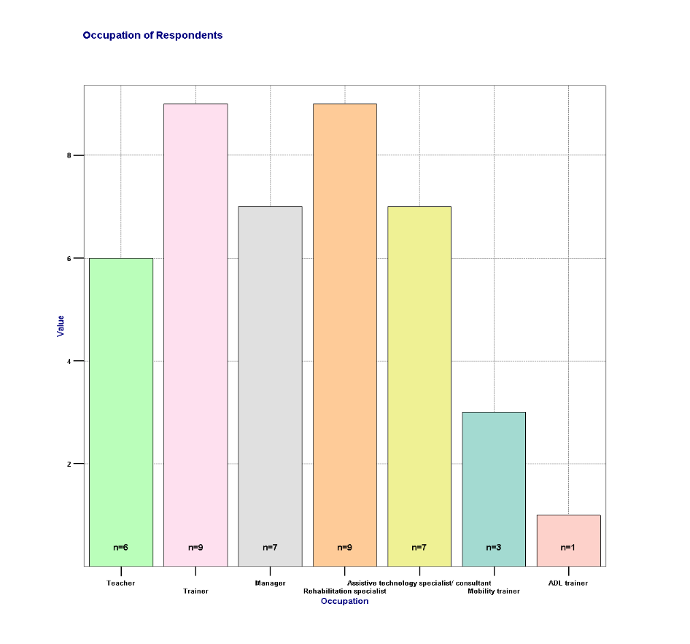

Free input ‘Other’

* Optometrist (1x)
* Development and Project Consultant (1x)
* Transcriber Braille (1x)
* Home trainer (1x)

### Country of residence

Item: “Please select your country”

|  | | Frequency | Percent | Valid Percent | Cumulative Percent |
| --- | --- | --- | --- | --- | --- |
| Valid | Austria | 3 | 9,4 | 9,4 | 9,4 |
| Belgium | 1 | 3,1 | 3,1 | 12,5 |
| Denmark | 1 | 3,1 | 3,1 | 15,6 |
| France | 3 | 9,4 | 9,4 | 25,0 |
| Germany | 7 | 21,9 | 21,9 | 46,9 |
| Hungary | 1 | 3,1 | 3,1 | 50,0 |
| Italy | 3 | 9,4 | 9,4 | 59,4 |
| Luxembourg | 1 | 3,1 | 3,1 | 62,5 |
| not specified | 3 | 9,4 | 9,4 | 71,9 |
| Portugal | 1 | 3,1 | 3,1 | 75,0 |
| Slovenia | 3 | 9,4 | 9,4 | 84,4 |
| The Netherlands | 5 | 15,6 | 15,6 | 100,0 |
| Total | 32 | 100,0 | 100,0 |  |

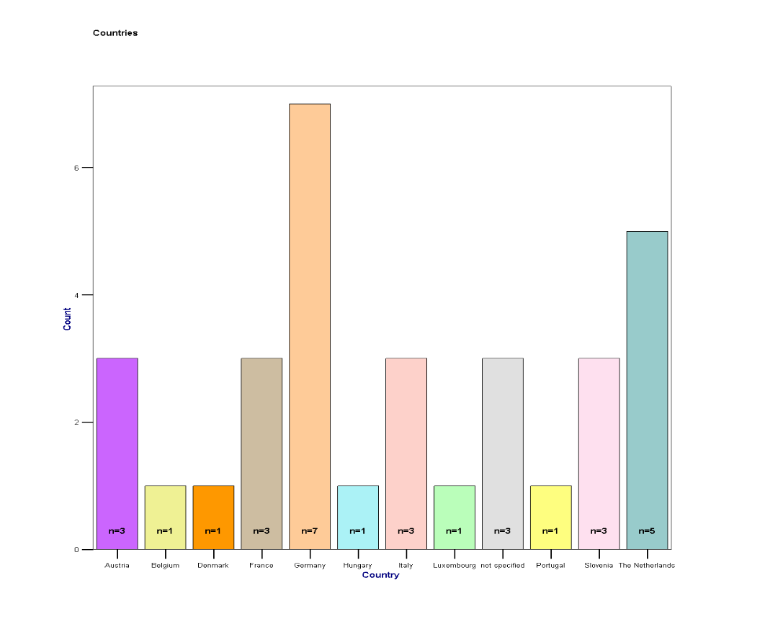

### Experience in work with the target group

Item: “How long have you been working with visually impaired individuals?”

|  | Cases | | | | | |
| --- | --- | --- | --- | --- | --- | --- |
| Included | | Excluded | | Total | |
| N | Percent | N | Percent | N | Percent |
| < 1Year | 3 | 9,4% | 29 | 90,6% | 32 | 100,0% |
| 1–5 years | 6 | 18,8% | 26 | 81,3% | 32 | 100,0% |
| 6–10 years | 4 | 12,5% | 28 | 87,5% | 32 | 100,0% |
| >10 years | 16 | 50,0% | 16 | 50,0% | 32 | 100,0% |

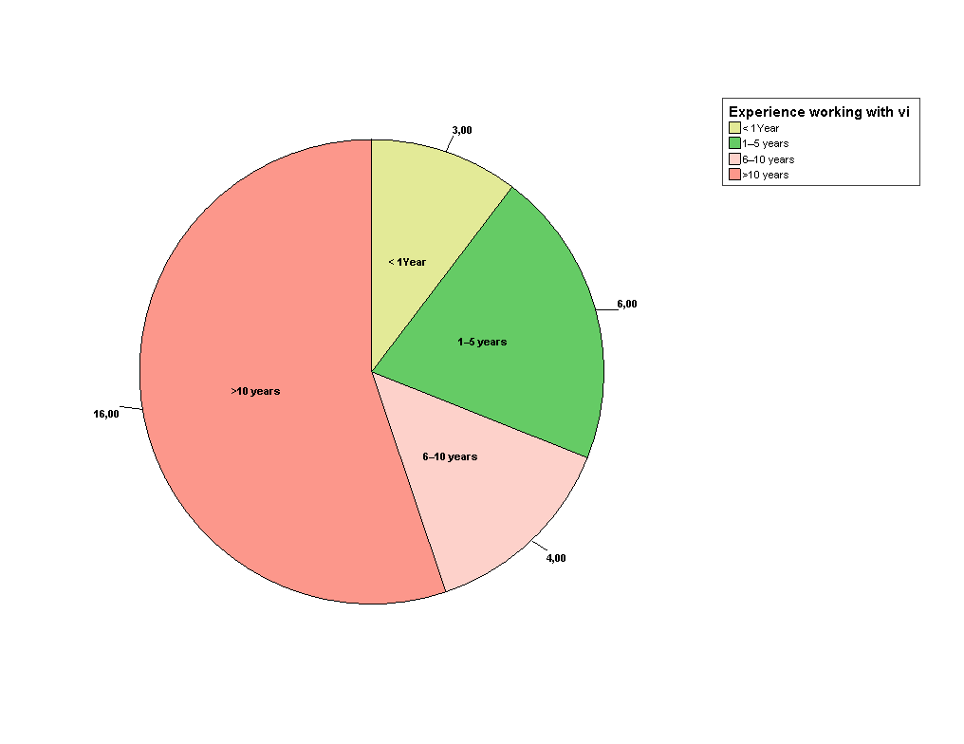

### Familiarity in using technology

Item: “How familiar are you with using technology in your work?”

|  | Cases | | | | | |
| --- | --- | --- | --- | --- | --- | --- |
| Included | | Excluded | | Total | |
| N | Percent | N | Percent | N | Percent |
| Not familiar | 0 | ,0% | 32 | 100,0% | 32 | 100,0% |
| Somewhat familiar | 5 | 15,6% | 27 | 84,4% | 32 | 100,0% |
| Very familiar | 27 | 84,4% | 5 | 15,6% | 32 | 100,0% |

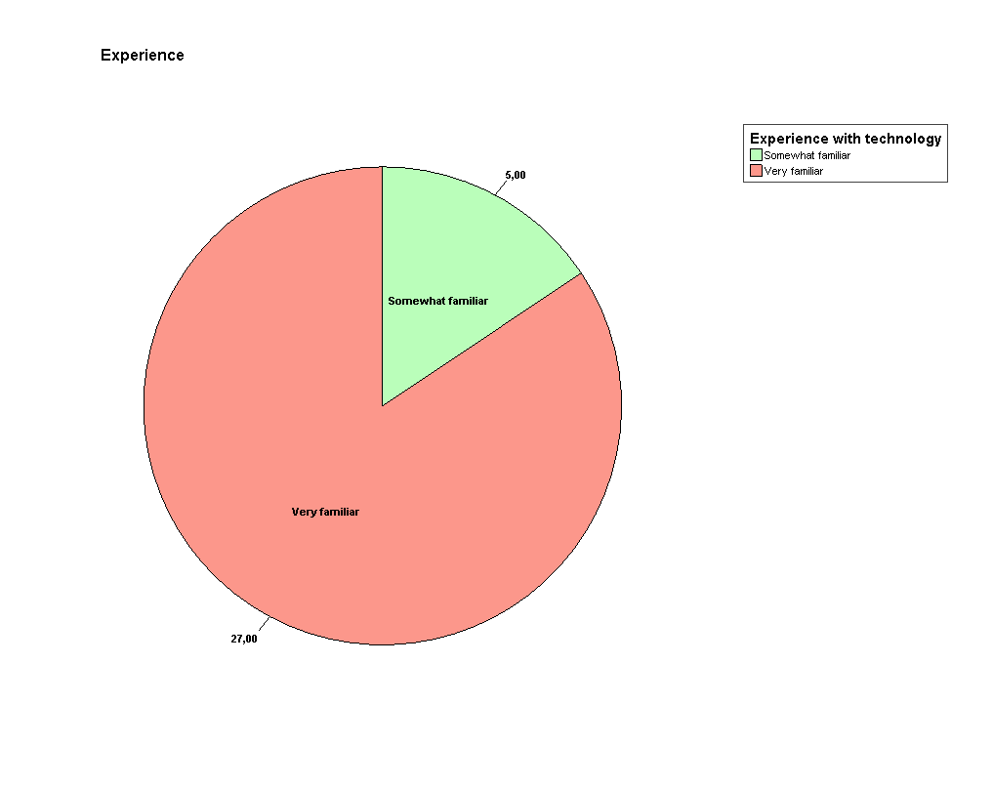

### Assistive technology used in supporting target group

Item: “What types of tools or devices do you currently use to assist visually impaired individuals?”  
(Multiple answer)

|  | Cases | | | | | |
| --- | --- | --- | --- | --- | --- | --- |
| Included | | Excluded | | Total | |
| N | Percent | N | Percent | N | Percent |
| Screenreaders | 21 | 65,6% | 11 | 34,4% | 32 | 100,0% |
| Braille devices | 20 | 62,5% | 12 | 37,5% | 32 | 100,0% |
| Mobile apps | 24 | 75,0% | 8 | 25,0% | 32 | 100,0% |
| Magnifying/ Camera systems | 18 | 56,3% | 14 | 43,8% | 32 | 100,0% |
| Magnifying software | 17 | 53,1% | 15 | 46,9% | 32 | 100,0% |

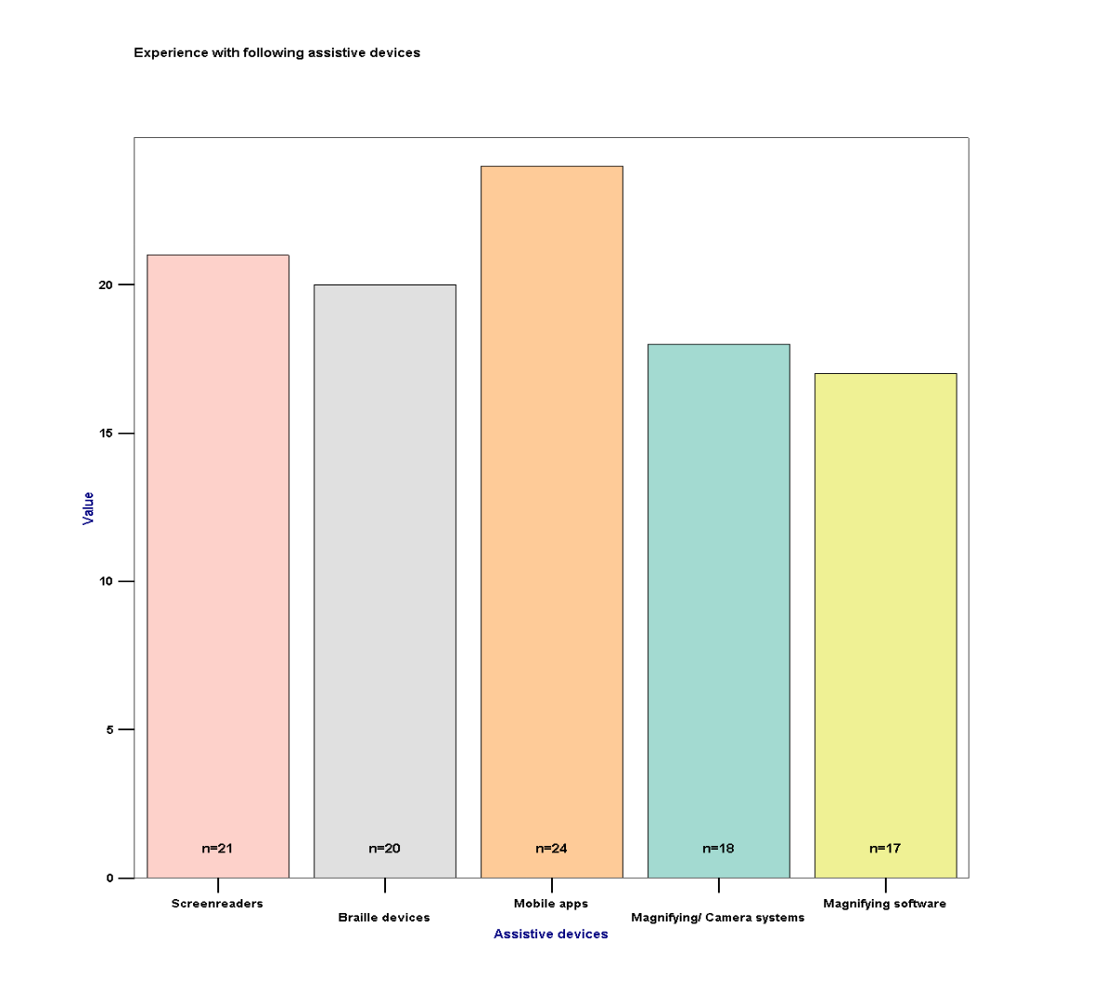

Free input ‘Other’

* NVT (n=1)
* NaviLens (n=1)
* Text-to-speech devices; devices   
  that enlarge or read out subtitles (n=1)
* Daisy Reader (n=1)

## Section 2 - Use of AI Mainstream Apps to Facilitate Education

### Utilisation of AI in training

Item: “Do you currently use AI-supported mainstream apps in your training sessions? “

|  | Cases | | | | | |
| --- | --- | --- | --- | --- | --- | --- |
| Included | | Excluded | | Total | |
| N | Percent | N | Percent | N | Percent |
| Yes | 13 | 40,6% | 19 | 59,4% | 32 | 100,0% |
| No | 9 | 28,1% | 23 | 71,9% | 32 | 100,0% |

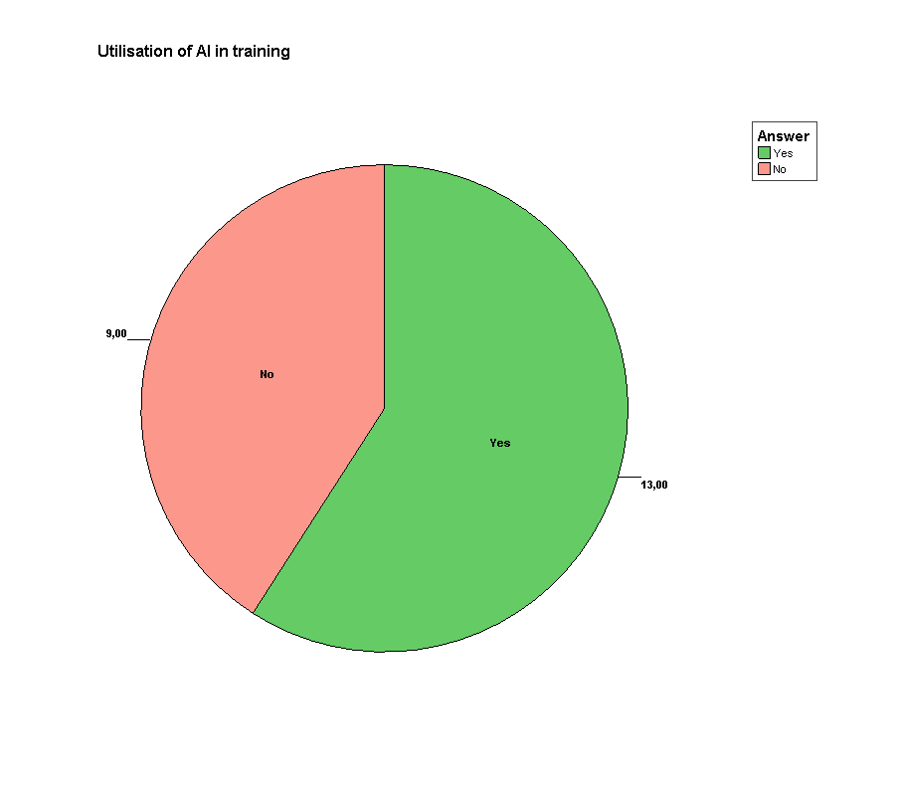

### AI Software in use

Item: “If yes, which apps do you use?” (Multiple answer)

|  | Cases | | | | | |
| --- | --- | --- | --- | --- | --- | --- |
| Included | | Excluded | | Total | |
| N | Percent | N | Percent | N | Percent |
| Chat GPT/ Open AI | 15 | 46,9% | 17 | 53,1% | 32 | 100,0% |
| Google Gemini | 8 | 25,0% | 24 | 75,0% | 32 | 100,0% |
| Neuroflash | 2 | 6,3% | 30 | 93,8% | 32 | 100,0% |
| NotebookLM | 3 | 9,4% | 29 | 90,6% | 32 | 100,0% |
| DaVinci AI | 1 | 3,1% | 31 | 96,9% | 32 | 100,0% |
| OpenArt AI | 1 | 3,1% | 31 | 96,9% | 32 | 100,0% |

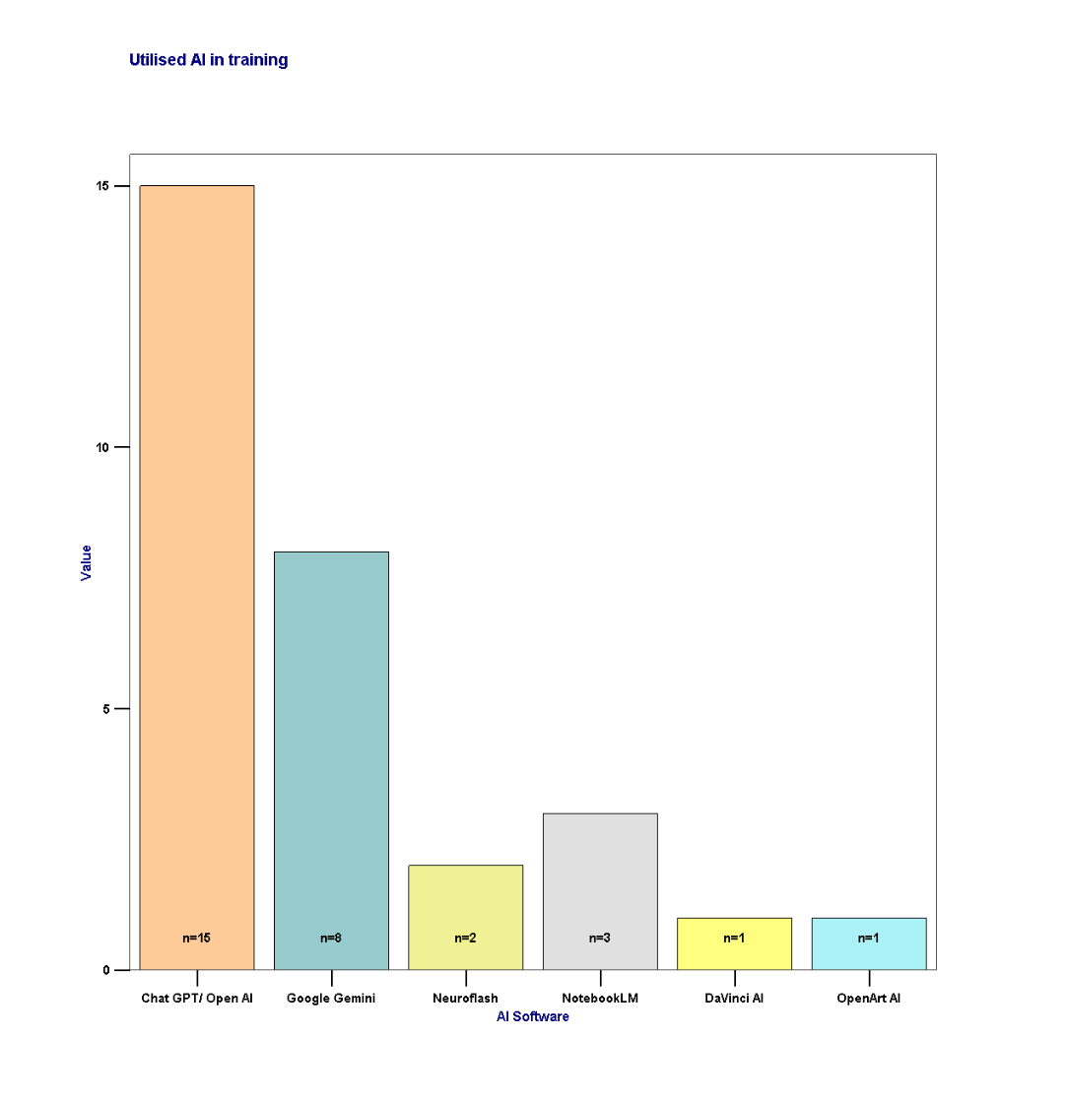

Free input ‘Other’

* BeMyEyes AI (n=4)
* SeeingAI (n=3)
* Microsoft Copilot (n=3)

### Effectiveness of these AI for educational needs of visually impaired people

Item: “How effective are these apps in addressing the educational needs of visually impaired individuals?”

|  | Cases | | | | | |
| --- | --- | --- | --- | --- | --- | --- |
| Included | | Excluded | | Total | |
| N | Percent | N | Percent | N | Percent |
| Not effective | 0 | ,0% | 32 | 100,0% | 32 | 100,0% |
| Somewhat effective | 6 | 18,8% | 26 | 81,3% | 32 | 100,0% |
| Very effective | 10 | 31,3% | 22 | 68,8% | 32 | 100,0% |

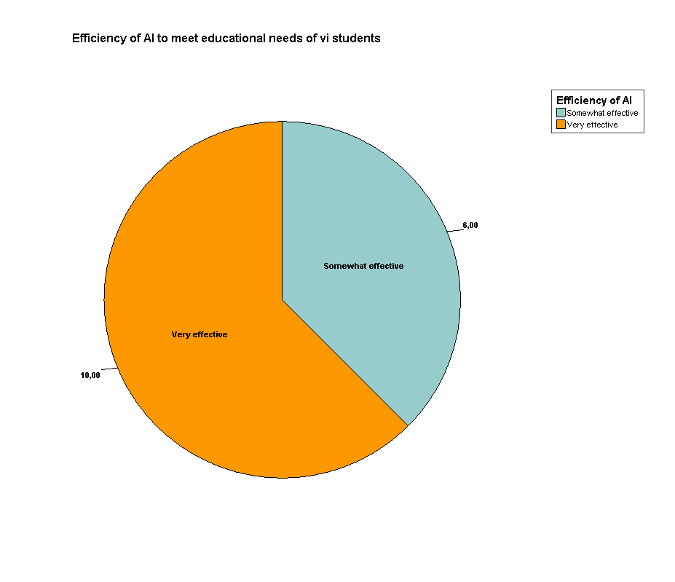

### Required features of AI to support work (Open question)

Remark: Input quoted exactly as typed

Item: “What additional features or tools would you like to see in mainstream AI apps to support your work?”

* Easier accessibility. ICT colleagues has given a course to visually impaired on how to use their JAWS for ChatGPT and another on how best to prompt their ChatGPT.; Some of our study councilors and teachers use AI for their own preparation.
* Video recognition; TTS subtitles with automatically a different voice for each character on the movie/program.
* Translating text into speech; Explaining pictures or rooms
* Externe camera support by Bluetooth, like a bodycam, without holding your iPhone holding op, this because of safety reasons
* AI-Powered Navigation & Object Recognition
* Text-to-Speech (TTS) and OCR Improvement
* AI-Powered Audio & Communication Tools

## Section 3: Use of AI Mainstream Apps to Facilitate Work

### Recommendation of AI to support visually impaired in working environment

Item: “How often do you recommend or use AI tools to help visually impaired individuals in their work environment?”

|  | Cases | | | | | |
| --- | --- | --- | --- | --- | --- | --- |
| Included | | Excluded | | Total | |
| N | Percent | N | Percent | N | Percent |
| Rarely | 2 | 6,3% | 30 | 93,8% | 32 | 100,0% |
| Occasionally | 4 | 12,5% | 28 | 87,5% | 32 | 100,0% |
| Frequently | 6 | 18,8% | 26 | 81,3% | 32 | 100,0% |
| Always | 2 | 6,3% | 30 | 93,8% | 32 | 100,0% |

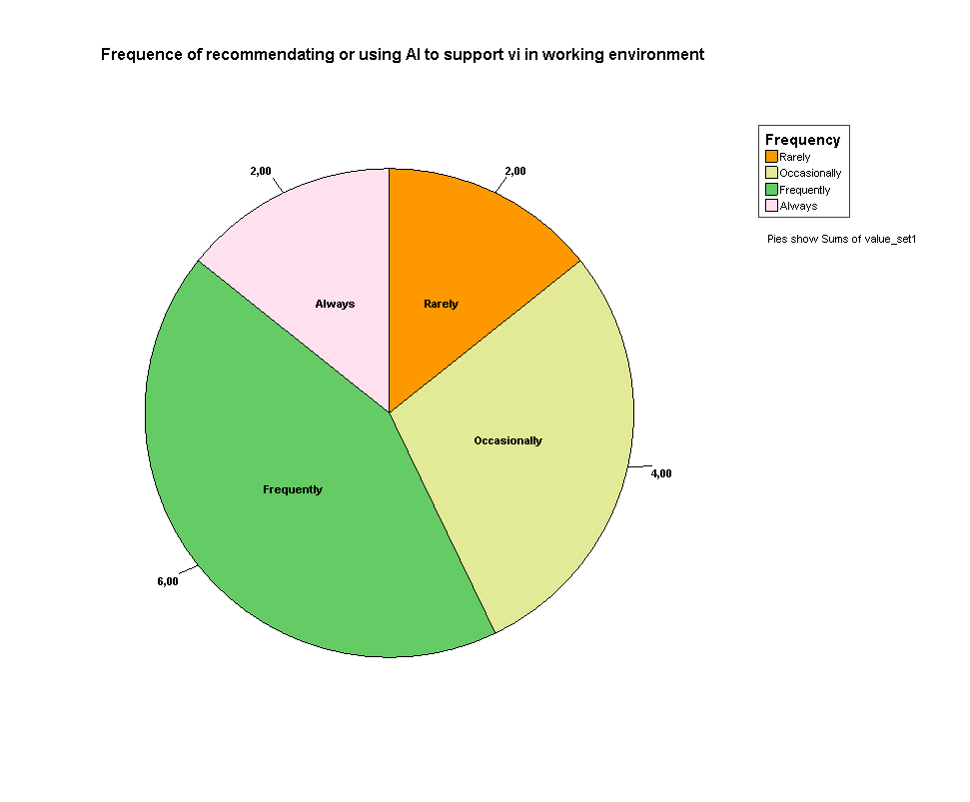

### Useful features in AI to facilitate work

Item: “Which AI tools or features do you find most helpful for facilitating work?” (multiple answer)

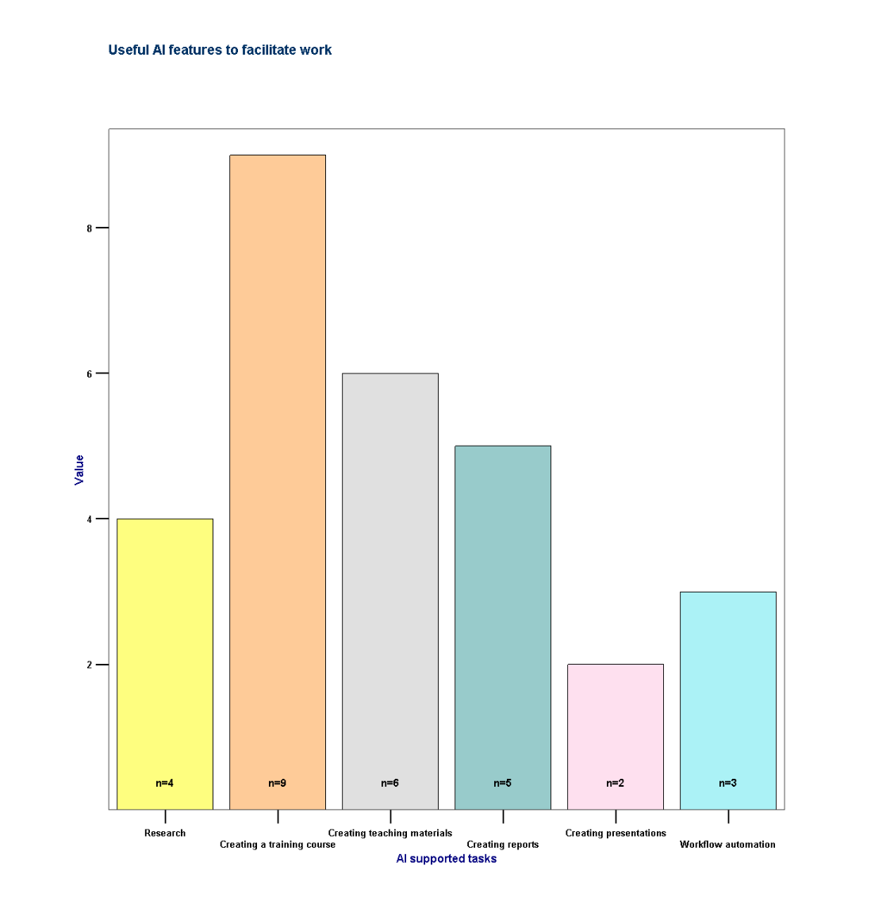

|  | Cases | | | | | |
| --- | --- | --- | --- | --- | --- | --- |
| Included | | Excluded | | Total | |
| N | Percent | N | Percent | N | Percent |
| Research | 4 | 12,5% | 28 | 87,5% | 32 | 100,0% |
| Creating a training course | 9 | 28,1% | 23 | 71,9% | 32 | 100,0% |
| Creating teaching materials | 6 | 18,8% | 26 | 81,3% | 32 | 100,0% |
| Creating reports | 5 | 15,6% | 27 | 84,4% | 32 | 100,0% |
| Creating presentations | 2 | 6,3% | 30 | 93,8% | 32 | 100,0% |
| Workflow automation | 3 | 9,4% | 29 | 90,6% | 32 | 100,0% |

Free input ‘Other’

* Recognition (n=1)
* description of visual aids (n=1)

### Encountered challenges while using or recommending AI for workplace? (Open question)

Remark: Input quoted exactly as typed

Item: “What challenges have you encountered while using or recommending AI tools for workplace support?”

* Partially too expensive
* Poor proofreading by participants, blind trust in the generated content
* The recognition of handwritten papers with check boxes is very hard
* AI Hallucinations creating wrong Sources and Links
* AI choice that allows attaching photos
* There is learning process that is taking time
* The work environment has to support the introduction of such tools
* The working team has to be educated about the benefits before it becomes a routine

### Suggested improvements for AI to use at workplace? (Open question)

Remark: Input quoted exactly as typed

Item: “What improvements would you suggest for AI apps to better support work-related tasks for visually impaired individuals?”

* Better contrast for predictions and guesses and labels for the reliability of results
* to be able to extract text from a scanned and handwritten page
* To enhance AI apps for work-related tasks for visually impaired individuals, improvements should focus on accessibility, efficiency, and adaptability
* 1 AI-Enhanced Productivity Tools 2. Improved Screen Readers & Navigation 3. AI-Assisted Communication & Collaboration
* 1. Accessible Data Handling & Visualization 2. AI for Workplace Independence & Security

## Section 4: Use of AI Mainstream Tools to Facilitate Everyday Life

### Recommendation of AI to support visually impaired in everyday life

Item: “How often do you recommend AI tools to visually impaired individuals for daily tasks? “

|  | Cases | | | | | |
| --- | --- | --- | --- | --- | --- | --- |
| Included | | Excluded | | Total | |
| N | Percent | N | Percent | N | Percent |
| Rarely | 1 | 3,1% | 31 | 96,9% | 32 | 100,0% |
| Occasionally | 5 | 15,6% | 27 | 84,4% | 32 | 100,0% |
| Frequently | 7 | 21,9% | 25 | 78,1% | 32 | 100,0% |
| Always | 1 | 3,1% | 31 | 96,9% | 32 | 100,0% |

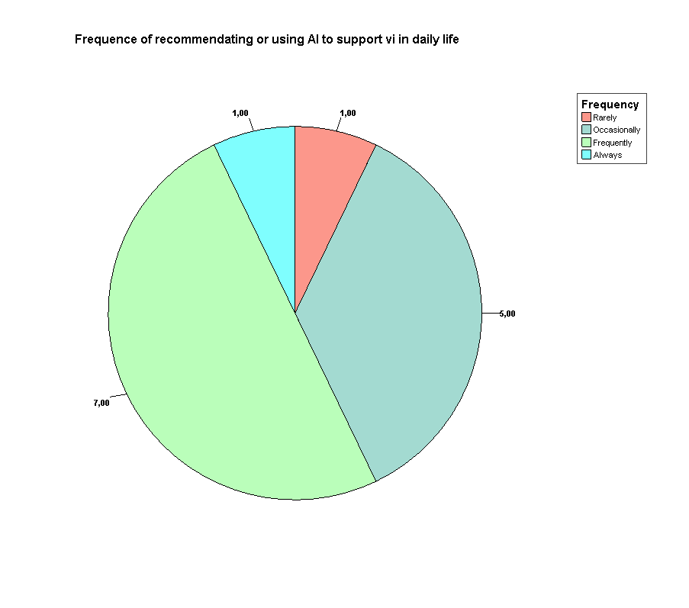

### Effective support of AI in tasks of everyday life

Item: “Which tasks do you think AI tools can most effectively support in daily life?”

(Multiple answer)

|  | Cases | | | | | |
| --- | --- | --- | --- | --- | --- | --- |
| Included | | Excluded | | Total | |
| N | Percent | N | Percent | N | Percent |
| Navigation and mobility | 10 | 31,3% | 22 | 68,8% | 32 | 100,0% |
| Shopping and payments | 8 | 25,0% | 24 | 75,0% | 32 | 100,0% |
| Reading and information access | 14 | 43,8% | 18 | 56,3% | 32 | 100,0% |
| Communication | 7 | 21,9% | 25 | 78,1% | 32 | 100,0% |
| Social interactions | 6 | 18,8% | 26 | 81,3% | 32 | 100,0% |

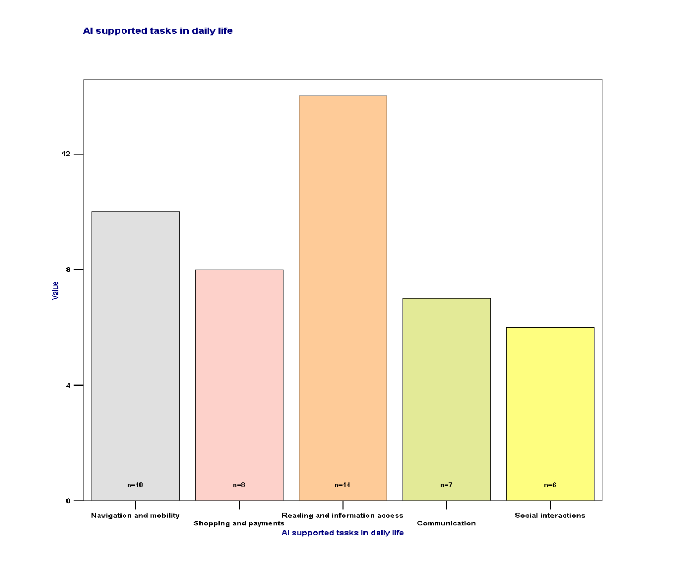

Free input ‘Other’

* Color detector (n=1)
* Via camera get descriptions of what is there in the surroundings (BeMyEyes)
* Recognition

### Limitations of AI for support everyday life? (Open question)

Remark: Input quoted exactly as typed

Item: “What limitations do you see in current AI tools for everyday life support?”

* Privacy, GDPR, AI´s imaginative powers to invent what is not there
* Data protection, prohibitive cost in long run
* to be able to extract text from a scanned and handwritten page
* While AI tools have made significant strides in supporting visually impaired individuals, they still have several limitations in everyday life support. Some key challenges include: 1. Accuracy & Context Awareness 2. Real-Time Responsiveness

## Section 5: Use of AI Tools to Generate Pictures

### Recommendation to use AI to generate tactile or descriptive images

Item: “Have you used or recommended AI tools for generating tactile or descriptive images for visually impaired individuals?”

|  | Cases | | | | | |
| --- | --- | --- | --- | --- | --- | --- |
| Included | | Excluded | | Total | |
| N | Percent | N | Percent | N | Percent |
| Yes | 7 | 21,9% | 25 | 78,1% | 32 | 100,0% |
| No | 6 | 18,8% | 26 | 81,3% | 32 | 100,0% |

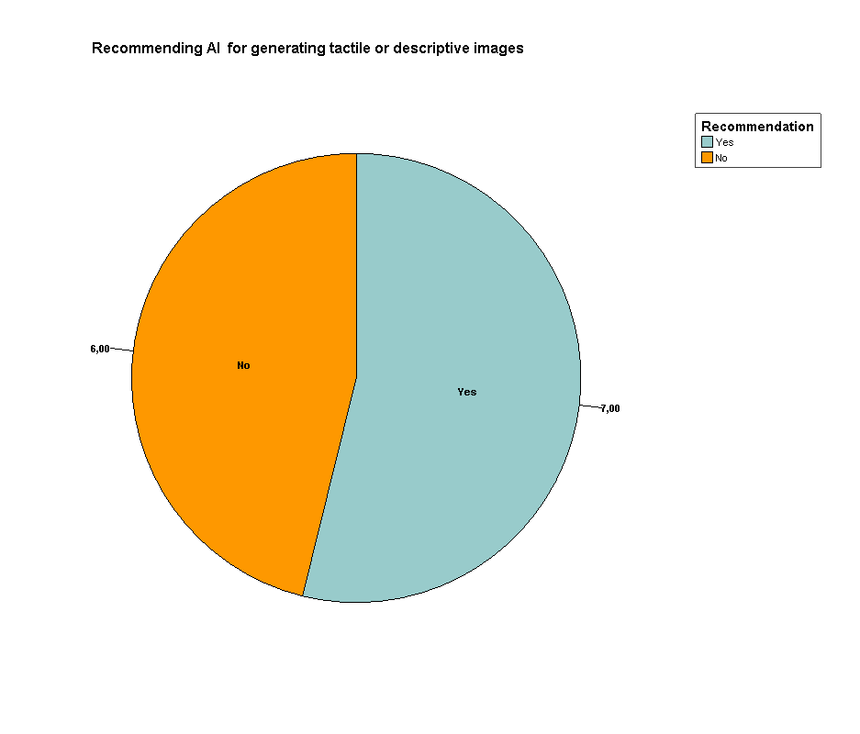

### Importance of AI to create visual content for visually impaired users

Item: “In your opinion, how important is the role of AI in creating visual content tailored for visually impaired users?”

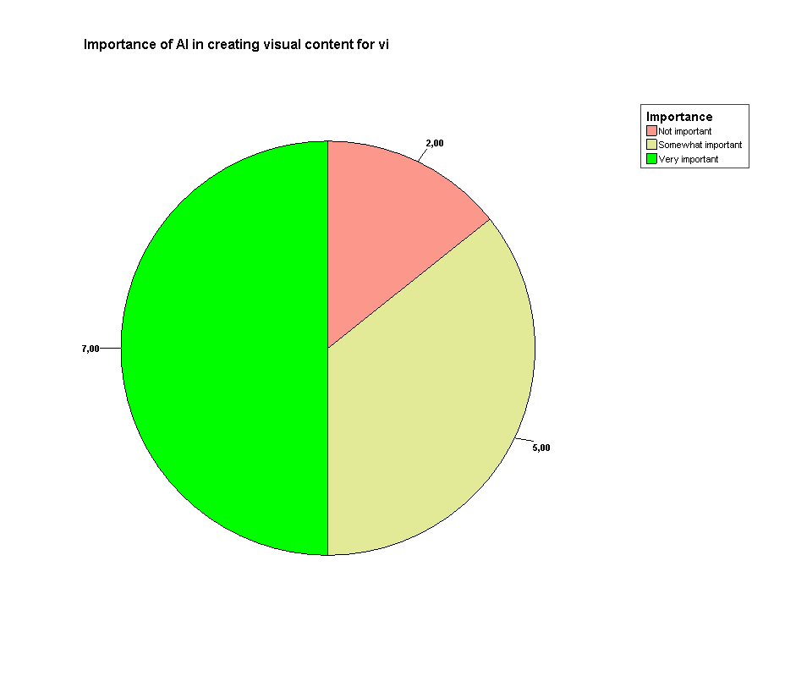

|  | Cases | | | | | |
| --- | --- | --- | --- | --- | --- | --- |
| Included | | Excluded | | Total | |
| N | Percent | N | Percent | N | Percent |
| Not important | 2 | 6,3% | 30 | 93,8% | 32 | 100,0% |
| Somewhat important | 5 | 15,6% | 27 | 84,4% | 32 | 100,0% |
| Very important | 7 | 21,9% | 25 | 78,1% | 32 | 100,0% |

### Utilised AI to generate tactile or descriptive images (Open question)

Remark: Input quoted exactly as typed

Item: “If yes, which tools have you used, and how effective were they?”

* Canva, Midjourney
* TactileView*
* Touch Mapper
* Tactile Image Maker (TIMG)*

* No AI tool, but Software to create images to generate tactile graphics

## Section 6: Concerns About Data Privacy

### Concerns about using AI supportet Apps

Item: “How concerned are you about the privacy of data when using AI tools for training purposes?”

|  | Cases | | | | | |
| --- | --- | --- | --- | --- | --- | --- |
| Included | | Excluded | | Total | |
| N | Percent | N | Percent | N | Percent |
| Not concerned | 2 | 6,3% | 30 | 93,8% | 32 | 100,0% |
| Somewhat concerned | 7 | 21,9% | 25 | 78,1% | 32 | 100,0% |
| Very concerned | 6 | 18,8% | 26 | 81,3% | 32 | 100,0% |

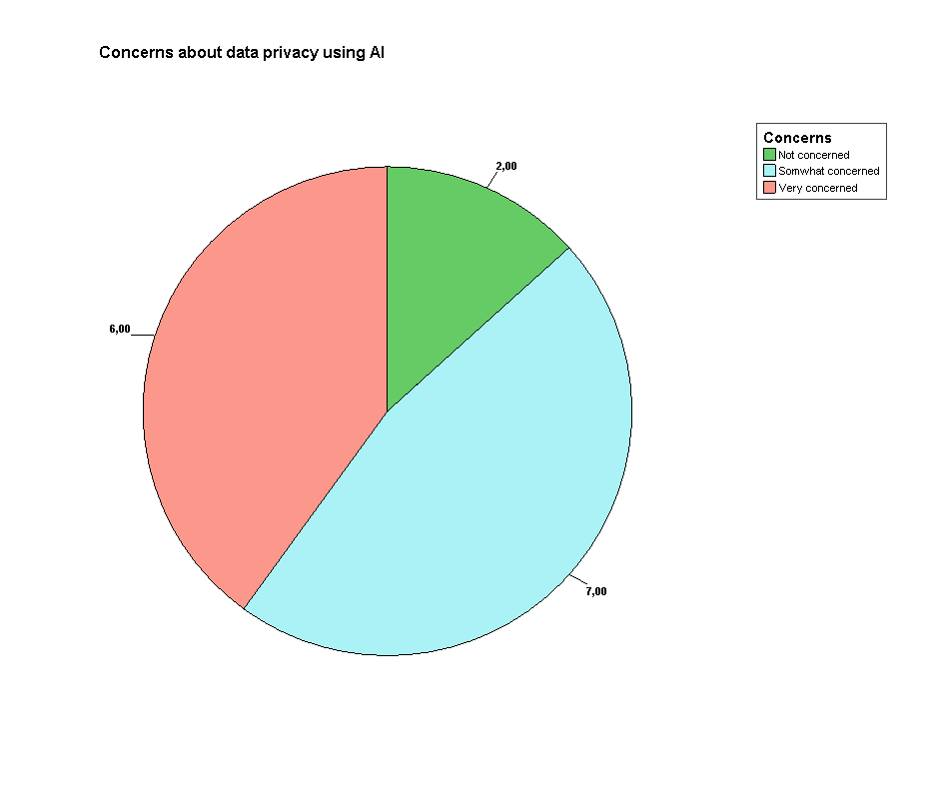

### Reasons for concerns about data privacy when using AI

Item: “Which aspects of data privacy concern you the most?”

(Multi answer)

|  | Cases | | | | | |
| --- | --- | --- | --- | --- | --- | --- |
| Included | | Excluded | | Total | |
| N | Percent | N | Percent | N | Percent |
| Collection of personal information | 11 | 34,4% | 21 | 65,6% | 32 | 100,0% |
| Sharing of data with third parties | 10 | 31,3% | 22 | 68,8% | 32 | 100,0% |
| Lack of transparency in data usage | 9 | 28,1% | 23 | 71,9% | 32 | 100,0% |
| Risk of security breache | 12 | 37,5% | 20 | 62,5% | 32 | 100,0% |

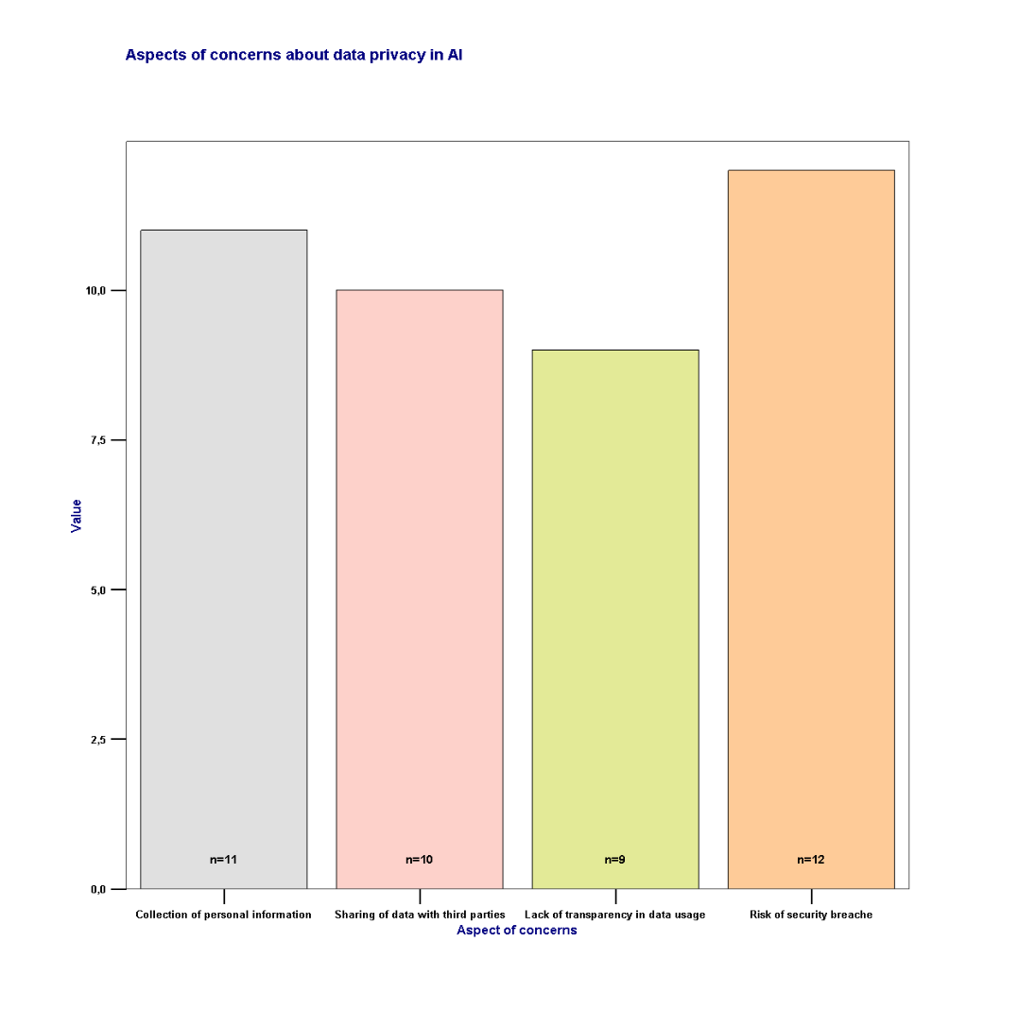

### Willingness to use AI despite of data privacy concerns

Item: “Would concerns about data privacy deter you from using AI tools?”

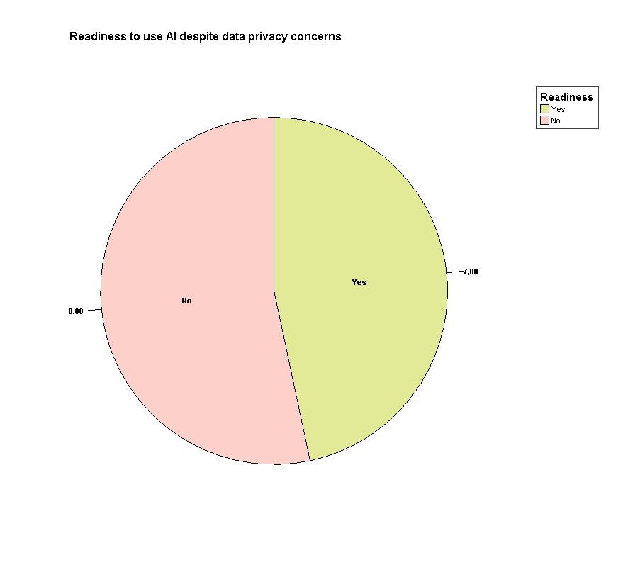=

|  | Cases | | | | | |
| --- | --- | --- | --- | --- | --- | --- |
| Included | | Excluded | | Total | |
| N | Percent | N | Percent | N | Percent |
| Yes | 7 | 21,9% | 25 | 78,1% | 32 | 100,0% |
| No | 8 | 25,0% | 24 | 75,0% | 32 | 100,0% |

## Section 7: Open Feedback

### What are your overall expectations from AI tools to better support your work with visually impaired individuals? (0pen question)

Remark: Input quoted exactly as typed

* They are great. There are many possibilities in this for some VIP individuals, but it also widens the gap for those who already finds the ICT difficult to use
* That visually impaired people can use simply to access documents on a daily basis (photos, mail) and for school use (extracting text from a page of a book for example)
* My overall expectations from AI tools are enhancing independence, accessibility, and efficiency
* AI tools that will be easy to learn and adopt in real life

# Remarks

During the ongoing survey, a complaint was received by email. The complainant criticised the lack of accessibility of the questionnaire. No further complaints, in particular regarding accessibility, were recorded.

# Bibliography

EUROPEAN PARLIAMENT AND COUNCIL OF THE EUROPEAN UNION 2024, *Harmonised rules on artificial intelligence and amending Regulations*, EC) No 300/2008, (EU) No 167/2013, (EU) No 168/2013, (EU) 2018/858, (EU) 2018/1139 and (EU) 2019/2144 and Directives 2014/90/EU, (EU) 2016/797 and (EU) 2020/1828 (Artificial Intelligence Act)

EUROPEAN UNION 2021, ANNEXES to the Proposal for a Regulation of the European Parliament and of the Council LAYING DOWN HARMONISED RULES ON ARTIFICIAL INTELLIGENCE (ARTIFICIAL INTELLIGENCE ACT) AND AMENDING CERTAIN UNION *LEGISLATIVE ACTS*

# Annex

The questionnaire for Expert is attached as offline version on the following pages.

# Section 1: General Information

Thank you for participating in this survey of the ERASMUS+ project "Visually Impaired people go for Artificial intelligence" (Abbrev. VIgo4AI). Your input will help us understand how AI can better support trainers and professionals working with visually impaired individuals in education, work, and everyday life. The survey should take approximately 10–15 minutes. Your responses are anonymous and will be used solely for research purposes of the project.

## 1.1 What is your primary role as a professional? (Mandatory question)

Teacher (If applicable enter 1 otherwise 0) Trainer (If applicable enter 1 otherwise 0) Manager (If applicable enter 1 otherwise 0)

Rehabilitation specialist (If applicable enter 1 otherwise 0)

Assistive technology specialist/ consultant (If applicable enter 1 otherwise 0)

Mobility trainer (If applicable enter 1 otherwise 0) ADL trainer (If applicable enter 1 otherwise 0)

Other (Please specify)

## 1.2 Please select your country (Mandatory question)

Enter your country here

## 1.3 How long have you been working with visually impaired individuals?

Less than 1 year (If applicable enter 1 otherwise 0)

1–5 years (If applicable enter 1 otherwise 0)

6–10 years (If applicable enter 1 otherwise 0)

More than 10 years (If applicable enter 1 otherwise 0)

## 1.4 How familiar are you with using technology in your work?

Not familiar (If applicable enter 1 otherwise 0)

Somewhat familiar (If applicable enter 1 otherwise 0)

Very familiar (If applicable enter 1 otherwise 0)

## 1.5 What types of tools or devices do you currently use to assist visually impaired individuals? (Select all that apply)

Screen readers (If applicable enter 1 otherwise 0)

Braille devices (If applicable enter 1 otherwise 0)

Mobile apps (If applicable enter 1 otherwise 0)

Magnifying/ Camera systems (If applicable enter 1 otherwise 0)

Magnifying software (If applicable enter 1 otherwise 0)

Other assistive technologies (please specify)

# Section 2: Use of AI Mainstream Apps to Facilitate Education

## Do you currently use AI-supported mainstream apps in your training sessions?

Yes (If applicable enter 1 otherwise 0)

No (If applicable enter 1 otherwise 0)

## If yes, which apps do you use?

Chat GPT/ Open AI

Google Gemini

Neuroflash.com

Google NotebookLM

DaVinci AI

OpenArt AI

Other (Please specify)

## How effective are these apps in addressing the educational needs of visually impaired individuals?

Not effective (If applicable enter 1 otherwise 0)

Somewhat effective (If applicable enter 1 otherwise 0)

Very effective (If applicable enter 1 otherwise 0)

## What additional features or tools would you like to see in mainstream AI apps to support your work?

Please add additional features you would like

# Section 3: Use of AI Mainstream Apps to Facilitate Work

## 3.1 How often do you recommend or use AI tools to help visually impaired individuals in their work environment?

Rarely (If applicable enter 1 otherwise 0)

Occasionally (If applicable enter 1 otherwise 0)

Frequently (If applicable enter 1 otherwise 0)

Always (If applicable enter 1 otherwise 0)

## Which AI tools or features do you find most helpful for facilitating work?

Research (If applicable enter 1 otherwise 0)

Creating a training course (If applicable enter 1 otherwise 0)

Creating teaching materials (If applicable enter 1 otherwise 0)

Creating reports (If applicable enter 1 otherwise 0)

Creating presentations (If applicable enter 1 otherwise 0)

Workflow automation (If applicable enter 1 otherwise 0)

Other (Please specify)

## What challenges have you encountered while using or recommending AI tools for workplace support?

Please enter here challenges you have encountered while using AI

## What improvements would you suggest for AI apps to better support work-related tasks for visually impaired individuals?

Please enter here improvements you would like to have in AI

# Section 4: Use of AI Mainstream Tools to Facilitate Everyday Life

## How often do you recommend AI tools to visually impaired individuals for daily tasks?

Rarely (If applicable enter 1 otherwise 0)

Occasionally (If applicable enter 1 otherwise 0)

Frequently (If applicable enter 1 otherwise 0)

Always (If applicable enter 1 otherwise 0)

## Which tasks do you think AI tools can most effectively support in daily life? (Select all that apply)

Navigation and mobility (If applicable enter 1 otherwise 0)

Shopping and payments (If applicable enter 1 otherwise 0)

Reading and information access (If applicable enter 1 otherwise 0)

Communication (If applicable enter 1 otherwise 0)

Social interactions (If applicable enter 1 otherwise 0)

Other (please specify)

## What limitations do you see in current AI tools for everyday life support?

Enter here the limitations you see in current AI tools

# Section 5: Use of AI Tools to Generate Pictures

## Have you used or recommended AI tools for generating tactile or descriptive images for visually impaired individuals?

Yes (If applicable enter 1 otherwise 0)

No (If applicable enter 1 otherwise 0)

## In your opinion, how important is the role of AI in creating visual content tailored for visually impaired users?

Not important (If applicable enter 1 otherwise 0)

Somewhat important (If applicable enter 1 otherwise 0)

Very important (If applicable enter 1 otherwise 0)

5.3 If yes, which tools have you used, and how effective were they?

Please enter here the tools you already used

# Section 6: Concerns About Data Privacy

## How concerned are you about the privacy of data when using AI tools for training purposes?

Not important (If applicable enter 1 otherwise 0)

Somewhat important (If applicable enter 1 otherwise 0)

Very important (If applicable enter 1 otherwise 0)

## Which aspects of data privacy concern you the most? (Select all that apply)

Collection of personal information (If applicable enter 1 otherwise 0)

Sharing of data with third parties (If applicable enter 1 otherwise 0)

Lack of transparency in data usage (If applicable enter 1 otherwise 0)

Risk of security breaches (If applicable enter 1 otherwise 0)

Other (Please specify)

## Would concerns about data privacy deter you from using AI tools?

Yes (If applicable enter 1 otherwise 0)

No (If applicable enter 1 otherwise 0)

# Section 7: Open Feedback

## What are your overall expectations from AI tools to better support your work with visually impaired individuals?

Please enter here your expectations

Thank You for Your Participation!

Your feedback is invaluable in shaping the future of accessible AI solutions and our ERASMUS+ project VIgo4AI